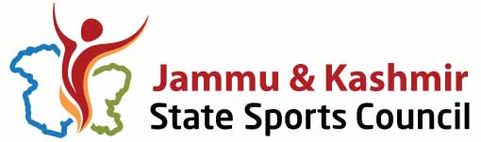

Subject: Supply of mats for different games.
Ref: Office e-NIT No 01 of 2018, dated 23-05-2018.

CORRIGENDUM
In view of issues brought to our notice by the various bidders, regarding the BOQ and the specifications given in the subsequent corrigendum, dated 29th May, 2018 and after due consultation and deliberation the technical committee has decided that the concerns raised by the prospecting bidders are genuine and cannot be overlooked. Thus the above referred to tender is hereby cancelled. Fresh tender will be floated in the coming days.
It may be noted that according to the new directions from Govt. of Jammu and Kashmir Civil Secretariat Finance Dept. vide O. M. No. A/24(2017)-651, dated 7th June, 2018 “Furnishing of hard copies after submitting the bids through e-tendering is dispensed with”.
The bidders who have already hard copies may kindly collect the hard copies from the Offices of the Secretary Jammu and Kashmir State Sports Council, Bakshi Stadium.

Sd-/
Secretary,
JKSSC.

No: SC/ 520-III / 2570-71
Date: 13-06-18
Copy to:
- Joint director Information Srinagar for publishing the corrigendum in two leading national and two local dailies.
- In charge website JKSSC for publication on the Sports Council website.

